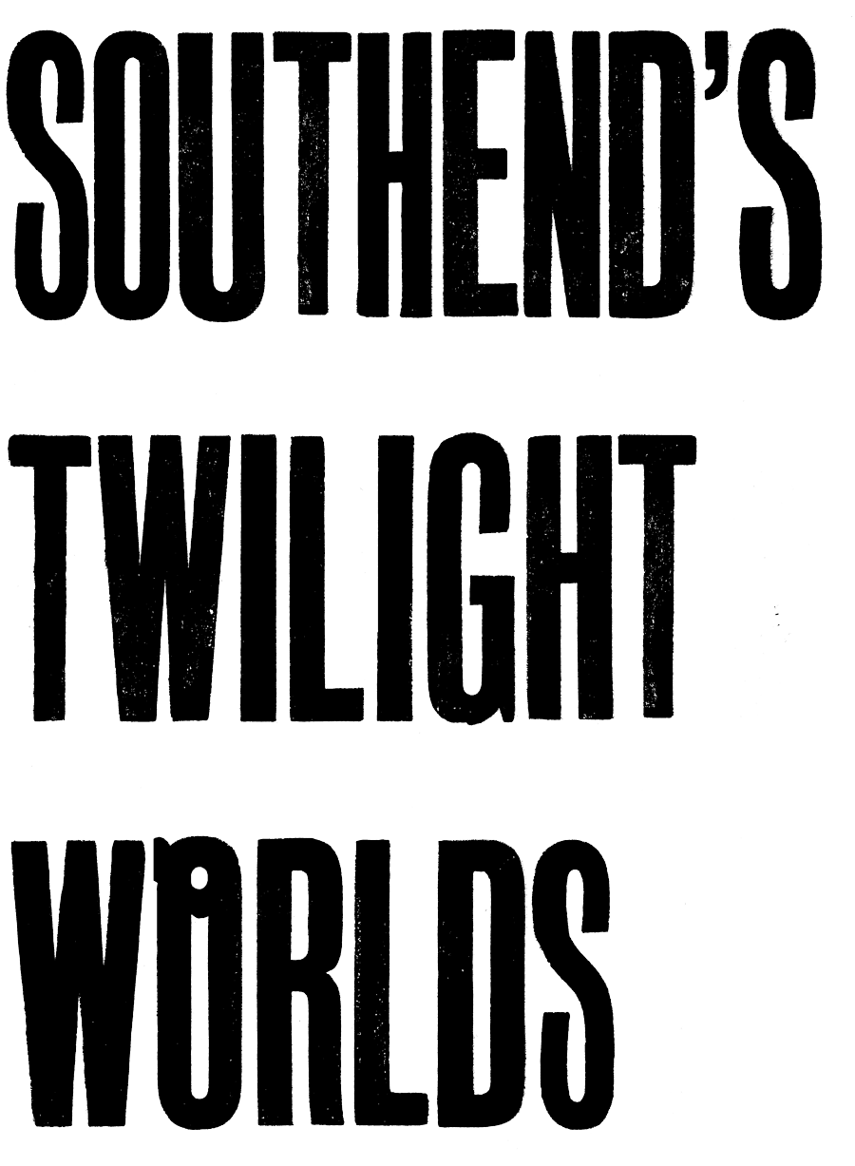

Access Friendly Handout Text

18pt, double spaced, plain font, text black on white.
In 1970, the Evening Echo published an investigation with the headline: ‘The Twilight Men of Southend’. Louis Blake, the article’s author, noted how there are around three to four thousand homosexual ‘men in fear’ who haunted Southend’s supposed twilight world. This was all in spite of the then recent introduction of so-called ‘well-meaning laws’– legalising homosexual acts under the premise that it was between two consenting adults over the age of twenty-one and carried out in private. Blake interviewed locals, often highlighting the violence and apprehension most experienced due to their sexuality, even how some of those interviewed discriminated against queers of colour.

‘Southend’s Twilight Worlds’ takes its title from this article, but the ‘world’ referred to in Blake’s article has become plural. This seeks to acknowledge that both then, and now, there are a vast number of communities with different experiences of living within Southend-on-Sea. While the project as a whole sets out to unearth queer histories from Southend, it does not aim to prolong some of the biases once held by the likes of the locals interviewed by Blake. Nor are its findings presented as absolute. Instead, the project is meant to encourage the public to continue to celebrate our differences within Southend-on-Sea, old and new.

Lu Williams has produced a banner, Southend’s Queer History 1965 to 2022 (2022) [1], which tracks the change in LGBTQ+ rights since 1965. Whilst acknowledging major events internationally, the majority of the events are smaller in scale and specific to Southend, visually highlighting how local activism and campaigning contributed to the rights queer people now have.

In Amy Pennington’s film commission “Where’s Danny?”
(2022) [2], they take on the role of a reporter named Barbara Standard. Standard’s reporting is fueled by gossip and rumour evoking the often disparaged nature of queer history. Drawing upon the headline ‘GAY SANTA GETS SACK’ from The Sun in 1986, and its appearance within a Derek Jarman painting, Pennington drags up to find out what really happened to the actor Danny Ford who was presumably dismissed from his role as Santa Claus in the historic department store Keddies.

Ruth Hazel’s series of patches titled Identify (2022) [3] explore the interconnection between language and self-expression. Badges were, and often still are, used to indicate a person’s beliefs. Hazel has created numerous badges which feature words such as ‘Witchy’ reclaiming an age- old derogatory term for women.

The Agency of Visible Women present their publication A Snapshot of Southend as a Cultural Environment for Womxn (2019) [4] that asked women and femmes to reflect on their experiences within the art and culture sector in Southend-on-Sea. Fifty-two of the responses are compiled with graphics overlaid with text in the ‘Mrs Eaves’ typeface that was named after Sarah Eaves, just one of the many overlooked women within the history of typography.

Scottee’s Most Homosexuals are Actually Incredibly Dull (2021) [5] is a painted text based work on MDF featuring the titular phrase. The phrase refutes the notion seen within the Evening Echo article, and today, that homosexuals are different from everyone else.

George Morl’s large scale painting Disposition of Digital
Youth (2019) [6] reflects on how queer spaces have increasingly become digitised since the early 2010s and how developments in radar technology in South Essex during the war gave rise to GPS - the groundwork for contemporary mobile apps such as Grindr and social media.

Josephine Melville presents a steel pan to signal the founding of Southend’s first community steel pan band Steel Here. The steel pan is rich with history, once a form of communication among enslaved Africans, and later popularised in Trinidad and Tobago in the 1930s and 50s by reusing discarded oil drums. A sample of the uplifting sounds produced by the Steel Here
band plays every five minutes [7].

Sunil Gupta presents Trespass 3 Untitled #9 & #13 for the second time within Southend-on- Sea, since its original exhibition at Focal Point Gallery in 1995. Untitled #9 [10] exposes the invisible overseas labour behind the tea trade as two locals on Southend’s seafront look over to a hut selling hot tea. Untitled #13 [9] foregrounds a queer presence in Southend through connotations implied by the first two panels depicting empty deck chairs and a public rest room alongside a Body Positive march: a support group for those diagnosed with HIV/AIDS, active between 1985 and 2000.
This project began with what at first seemed like an utterly unanswerable question: does Southend have a queer history to tell? ‘Southend’s Twilight Worlds’ argues that there is an alternative past and present of Southend, whilst urging for a vibrant future.

NUMBERS CORRESPOND TO THE POSITION OF EACH ARTWORK ON THE MAP ON THE REVERSE

